Motivation and retention of Volunteers in festivals and events

Author: Henrik S. Pahus, Senior Lecturer at Dania Academy for higher learning

E-mail address: hpa@eadania

Postal address: Dania Academy. Minervavej 63, 8960 Randers SO. Denmark

Keywords: Motivation, retention, festivals, events, volunterism…

**Abstract**

This paper is based on an ongoing research project into motivation and retention of volunteers on festivals and events. The overall project is conducted in collaboration with “Muskelsvindfonden”, which is a Danish foundation that runs several larger festivals on the Danish festival market (Grøn Koncert, Roskilde festival and Cirkus Summarum). [1] The overall research project spans from 2017 – 2020, and aims to answer questions of future motivational drivers for volunteers in festivals and events on the Danish market.

The preliminary results suggests that there are three overall motivational topics, which seem to motivate the volunteers at the festivals arranged by Muskelsvindfonden: 1) Directed towards the ***community*** that one enter as a volunteer. 2) The personal gain that one achieves as a volunteer, where elements of ***self-realization*** becomes prominent. 3) There is the element of contributing to a worthy cause, namely the ***purpose*** driven motivational factors.

**Introduction**

Volunteerism in general is a growing trend within most European countries. We meet the voluntary workforce in many guises, from the local football coach, to the hot-dog vendors at the festivals we attend. The monetary value of the volunteers that contribute with their work every day, is however tricky to access, but there is no doubt, that several businesses depend heavily on a voluntary workforce.

Based on a literary review previously conducted, there is however a scarcity of research on motivation and retention of volunteers within the event and festival business. Thus, the focus of this ongoing research project is to examine motivation and retention of volunteers specifically within larger festival and events in Denmark.

The reason for choosing Muskelsvindfonden as my research partner is, that I have worked with them since 2015 in various projects concerning how they could improve their customer delivery system. During this process, it became clear, that further research into the motives and reasoning for becoming a volunteer at a festival, was needed. Although the festival continually conduct surveys with their volunteers, it was however elusive what the primary reason for motivation and retention among the volunteers were. This was confirmed by the Management of the festivals, and thus this became the topic of this project.

**Methodology**

The overall research paradigm in this project is the pragmatic worldview, and the research design is Exploratory Sequential Mixed Methods[2]. In the summer of 2018, the research team held semi-structured interviews with 26 volunteers on festival places around Denmark (all of the festivals we visited were run by Muskelsvindfonden)[3]. The questions were aimed at exploring the reasons for why people become volunteers (motivation), and subsequently the reason for why they stay volunteers (retention).

In addition to this, we did an observational analysis based on a predefined observational frame on the different festivals mentioned above[4]. Lastly, we had 150 respondents in a quantitative analysis, which we distributed in the fall of 2018 to volunteers. A significant methodical challenge was however, to use quantitative and qualitative data in connection to forming the personas[5]. As a consequence of this, I have primarily used the qualitative data to support the personas, and primarily used the quantitative data to elaborate some of the demographic variables such as age, gender, maritial status with ects.

**Findings – so far!**

Based on the interviews we conducted with the volunteers in the summer of 2018, I tried to look for commonalities among the volunteers from the different festivals. Overall, I found three distinct topics that seemed to concern the volunteers to a varying degree. My conclusion is however, that much like a personality test, the volunteers could not be divided into archetypes that were motivated solely by one specific thing. On the contrary, I found that all of them were motivated by a combination of the three following topics:

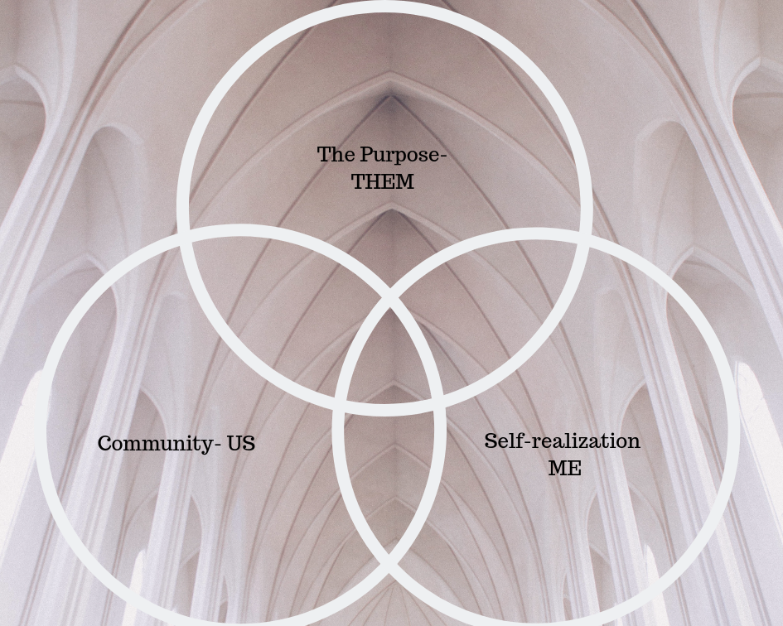

Figure 1: The three main motivational topics

**The three types of motivation**

Below I will describe the fundamentals of the three motivational topics I uncovered, and how they relate to each other.

Community/US

The first topic we uncovered was the notion of Community, which the volunteers expressed. This was however, perceived in various ways, which I will elaborate below.

* Getting a new “family/festival family”: Through the relations that the volunteers build with other volunteers during the Summer, several highlighted the new “family” they gained as a volunteers.
* Rituals, traditions and stories: A way of feeling like a part of the community was through the many traditions and rituals that occur during the period you are a volunteer.
* The internal Language: Like rituals and traditions can set the frame for the perception of community among the volunteers, so can the internal language help to define your relation to Muskelsvindfonden and your fellow volunteers. Specific terms and phrases helped to create the sensation of being part of something special and unique, and through the linguistic discourse, the volunteers identified themselves as part of the “family”/group as described in the first bullet point
* Affiliation: While the “festival family” and the “traditions” as mentioned above were attached to something specific (your team on the festival for example), several expressed that you also had an important bond with all the other volunteers on the specific festival. Thus, this kind of affiliation is connected to the festival in general.
* Parties and socializing outside the festival: Even though the most important part of forming a community happened while the volunteers were active in their voluntary work, several also emphasized that a crucial element in maintaining a sense of community, happened outside of the festival – Christmas parties, Eftersluk (The name of a specific party arranged by the festival during the fall) and other formal and informal social events.

Demotivators

* + The absence of community – especially within the team you are assigned.
  + Communication gaps between the volunteers and the employees at Muskelsvindfonden
  + Conflicts between the volunteers and the employees at Muskelsvindfonden

Self-realization/ME:

The second topic that I discovered falls within the more common notion of motivation – the personal gain.

* Escapism: This element can be divided in to two parts, which motivates differently, but are still connected by the need to escape the everyday life. This is not necessarily connected to the fact, that one has problems, or is seeking to escape something negative, but more that the role as a volunteer offers the opportunity to live out something that is not possible in the everyday life. One of the ways to experience escapism as a volunteer is, that you seek *“to go into something”,* and live out the experience of being a volunteer. This was especially clear, when looking at the volunteers at the “Circus Summarum” event[6] where several of the respondents emphasized the ability to immerse themselves into a “childish universe” and the possibility to rediscover the joys of “childishness” once again. The opposite of *“going into something”* was the option to *“get away from something”.* Whereas the previous element of going into something was primarily expressed by volunteers from the Circus Summarum festival, this was something that volunteers from all the different types of festivals expressed clearly. The driving force here was the option to do things that differed from your everyday life. Some of the respondents who in their everyday jobs worked in an office, found profound joy in the option to “work with their hands”, and to “use their bodies in manual work”.
* The creation of something impossible (soldier stories): This part is highly connected with the affiliation element previously mentioned under the community dimension – being part of something bigger. In this case however, the motivation comes by achieving something that appears impossible. An example of this is the building of the festival scene, which has to be done in an extremely short amount of time. The feeling of doing this in one’s group, generated a high level of motivation for several of our respondents
* Self-development: Through your job as a volunteer, you develop new competences, which can be used after the event is over. This may be tangible competences, like doing electricity jobs, or learning how to use a drilling machine, but also learning more broad competencies like social skills, and accepting others.
* Satisfaction of egotistic needs: Unlike many of the other elements, this is solely focused upon achieving satisfaction and fulfillment of oneself, through the work as a volunteer. Among other things, the need for others to see one as “a decent person” was a primary motivator.

Demotivators

* A lack of development in one’s role as a volunteer: This is especially a predominant feature for those who had worked as volunteers for several years. They felt demotivated due to a lack of challenges/development in their role as volunteers. This was especially connected to self-development.
* Conflicts with the everyday life: A lack of energy due to a stressing job, having a family and more.
* Too much negative focus on the basic thing: An element that disrupted one’s ability to immerse oneself as a volunteer, was the focus on basic things that the volunteers felt were lacking – proper sleeping facilities, healthy food, sanitary conditions.

Purpose/THEM:

The primary purpose of Muskelsvindfonden, and the concerts that they arrange, is to raise money to help people in Denmark affected by muscular dystrophy. This is actually also embedded in the name of the organization itself, as the name “Muskelsvindfonden” directly translates into “The foundation for muscular dystrophy”. Thus, the purpose driven motivation was the third overall topic identified among the volunteers!

* The personal connection: You know someone who is afflicted by muscular dystrophy, and that is why you become a volunteer. Several of the volunteers also emphasized, that getting to know someone with the disease (for example by meeting them during their work as a volunteer), was a substantial retention factor.
* Giving something back (charity): Instead of going around with a collection box on Sundays, this is seen as a way to help the overall cause. Quite a few volunteers on especially Roskilde festival in Copenhagen, emphasized this a substantial form of motivation.
* What you get for the money raised on the festivals: As previously mentioned, the money raised at the festivals goes to support people afflicted by muscular dystrophy. Among other things, they are used to enhance research, and to run holiday resorts specifically minded upon people with muscular dystrophy. This was also mentioned as highly motivating, with specific stories of how the volunteers had experience, how the money that the generated was put to work.

Demotivators:

* Lacking knowledge of the officially stated purpose
* Lacking knowledge about the overall story of Muskelsvindfonden and the story of their founder “Ewald Krogh”

**Future research?**

The next fase in the research process, is to develop volunteer personas, that Muskelsvindfonden can use in their daily work, to both motivate and retain current volunteers, but also in the recruitment process. The Personas will be based upon the three overall topics from this paper. Furthermore, it is the aim of this project to develop a theoretical framework. Festival managements (both in Denmark, but also abroad) can use this to work with the motivation and reasons for retention of the volunteers. The theoretical framework combined with the personas will then be put together in a handbook that festivals can use for training their leaders in motivation and retention of volunteers.

Literature list

Brinkman, S and Kvale, S (2015): InterViews - Learning the Craft of Qualitative Research Interviewing. SAGE Publications

Creswell, J.W (2014): Research Design. SAGE Publications

1. For further information regarding the festival and the organization, please visit their webpage on https://muskelsvindfonden.dk/
2. Creswell, 2014
3. Brinkman and Kvale, 2015
4. Brinkman and Kvale, 2015
5. The next step in the project is a make voluntary persona catalogue for Muskelsvindfonden, and the findings in this paper will be used to support this.
6. Circus Summarum is a children’s festival based on famous characters from Danish television