Innovation Camp – what, why and how?
Susanne Østergaard Olsen*
Business Academy Aarhus, Sønderhøj 30, 8260 Viby J, Denmark.
E-mail: suol@eaaa.dk
Tri Sugiarto
Universitas Negeri Yogyakarta, Kolombo Street, Karangmalang, Yogyakarta, Indonesia 55281.
E-mail: trisugiarto@uny.ac.id
Handrich Kongdro
BINUS University International (JWC-fX Campus), Jl. Hang Lekir I No. 6, Senayan, Central Jakarta, Indonesia 10270.
E-mail: hkongdro@binus.edu
Jesper Nørskov
Business Academy Aarhus, Sønderhøj 30, 8260 Viby J, Denmark.
E-mail: noje@eaaa.dk
*corresponding author
Abstract
The perspective of this article on Innovation Camp is practical and empirically based, with focus on what, why and how, with the purpose of providing basic recommendations for doing innovation camps. The article covers the rationale and motivation for both students, lecturers and educational institutions in doing innovation camps. We will include the what, why, context and implementation of Innovation camp at Binus University and Yogyakarta State University. The choice of implementing innovation camp among all the INDOPED innovative pedagogical methods was, in itself, an innovative choice for the two Indonesian Universities. It brought with it different experiences and implications, but also great wins and motivation. As the European “train the trainer” institution, Business Academy Aarhus was impressed by the enthusiasm and engagement from the lecturers and students, as well as the motivation for and results of the implementation. The joint experiences and evaluations will lead to a recommendation on why and how to do an innovation camp.
Keywords
Innovation; pedagogical methods; entrepreneurship; camp guideline; teacher role; student driven learning.
October 2018

1. Innovation Camps - origin
Innovation camp is one of the new innovative learning methods piloted in the INDOPED project. Innovation Camp is an intensive idea generation, idea development and innovation process method, where students from different educational programs are working together in interdisciplinary and cross-curricular teams in order to solve a specific issue or challenge for a company, an industry or a NGO.
Professor emeritus Torben Bager from University of Southern Denmark introduced the idea of Innovation Camp, as a method to teaching entrepreneurship at an EFMD Conference in Barcelona in 2009. Torben Bager was at the time, and still is, the leading dean at the IDEA Entrepreneurship Centre, University of Southern Denmark. Before that, the concept of Innovation Camp developed and materialized itself in a collaboration between University of Southern Denmark, Business Academy South West and Business Academy Aarhus. In 2013, an official EU Camp Guide was published as a practical guide for educational institutions in the EU. Business Academy Aarhus has been the forerunner in planning and implementing Innovation Camps in Denmark since 2004, where the first Innovation Camps took place. Since then, Business Academy Aarhus is one of the most experienced in planning and implementing numerous Innovation Camps with different themes, business partners and students. Business Academy Aarhus is one of the European partners in the INDOPED project, and is a university of applied science with seven different faculties.
The Innovation Camps represent the very essence of the pedagogical and educational platform for Business Academy Aarhus. The fundament in the platform is "close to practice", meaning, that the industry context, which students must work in, after graduation, is the starting point for all pedagogy. The core value is “Insight provides perspectives, only action brings true transformation”. Learning at Business Academy Aarhus is student centered, (SCL) and teaching is a dynamic, interactive process with emphasis on active student participation. This results in a combination of classroom teaching, project work in groups and individual work - often involving cross-curricular issues and always with a practice-oriented basis including solving relevant issues and challenges for companies. Business Academy Aarhus has a close relationship and collaboration with a large number of especially small and medium sized enterprise in the region, where it is situated. The reason why, Business Academy Aarhus do many Innovation Camps is that it is an accurate implementation of the teaching principles, following the overall pedagogical and educational platform. In addition, it is an efficient mean to give the students skills, which enable them to succeed in a dynamic, ever-changing 21st century working place, whatever they pursue a career as an employee or an entrepreneur.
What is innovation camp?
In Innovation Camps, the participants cooperate in interdisciplinary teams, usually 4-6 students in each team, on a common issue, problem or challenge. The camp content will alternate between presentations, practical work, presentations and feedback. The participating students are under pressure with tight deadlines, which always ends with a presentation of the preliminary results.
The starting point is a specific challenge, formulated in cooperation between the company, a NGO or governmental organization and the educational institution. In the INDOPED pilot, this was the responsibility of Binus University and Yogyakarta State University. The camp manager (the lecturer designated to that role) controls the process along with a number of process guides or facilitators, all trained to manage a short and intensive innovation process.
Time pressure and interdisciplinary, cross – curricular teams push the participating students out of their comfort zone, and preferably, the participants work outside their familiar surroundings. If it is possible to arrange the innovation camp to take place outside campus, as it was the case in the pilot at Yogyakarta State University and partly Binus University, it ensures the best opportunities for innovational height in the collaboration and in the final solution to the challenge.
The organization of camp make the participants pass through a creative, collaborative and innovative process, which focuses on the relationship between problem and solution. The innovation process, used at Business Academy Aarhus and in this pilot, is the 3-zone innovation process tool. This innovation process tool is experience based, developed in a combination of practical learning and action research context by Business Academy Aarhus. The innovation process tool by Business Academy Aarhus is the yellow, green and red zone, and it consists of three phases, that the team is going through after the presentation of a problem/challenge/opportunity. The yellow zone is establishing a basic understanding of the problem, the green zone is the idea development, (the creative phase), while the red zone is sorting and idea selection. The method relates closely to the Design Thinking Model (Stanford University, USA), as the yellow zone represent the “Empathize and Define” phase, the green zone is the “Ideate” phase and the red zone correlates the “prototype and test” phase.

Yellow zone: Problem/challenge understanding and defining the problem statement to work with.
The main parameter in the yellow zone is that the team is working to obtain a common understanding or framework of the overall problem. The team discuss definitions, frame the understanding of domain and problem and pinpoint the problem, so that it works in the context of the team and everyone understands it. Data and information collection is often necessary in order to address and clarify lack of understanding of the problem. In the yellow zone, the team must achieve a satisfactory level of knowledge for the problem area and the problem itself before the team can proceed to the green zone. However, the team should not be experts or crush their own creativity in data collection. The team defining the focus in the problem area that it will work with must complete the yellow zone. Several specific exercises are recommended (and available on request) for use in the yellow zone.

Green zone: Ide generation.
In the green zone, it is important that the team has agreed on rules for the cooperation in the team process, including that” everything goes”, meaning that everyone is positive and that nobody rejects any ideas. The team must constantly move forward and not "just" fall in love” with its first idea. It is about getting as many ideas as possible at all, which is why creative exercises are good tools. It may also be a good idea to switch between working individually, work together two and two or the whole team. Specific exercises recommended for use in the green zone include brainstorming, words- picture association, and several others. (Available on request).

Red zone: Sort, evaluate and combine ideas.
The red zone is usually easy for most participants to work in because it resembles a “normal” educational process, and it is often far easier to "crush" ideas than to get them. In the red zone, however, it may be a challenge to "kill your darlings". This means that it can be difficult to work structured with the red zone, as many teams have already formed an opinion on what idea they want to work on with, without really considering why. Therefore, a structured process through the red zone is crucial. Specific exercises are recommended (and available on request) for the red zone. The team can use the tools in a chronological order, replace an exercise with another, or skip an exercise entirely. If the team feels it is necessary to go back to the green zone, it is just healthy to go back and develop the idea even more.
A camp runs over 8 to 48 hours with participating from at least 12 people. The program for the innovation camps varies, depending on the challenge and the sponsoring company. However, the set-up of the camp is usually as follows:

- If possible, the camp always takes place close to the company/organisation, which is producing the challenges. Being close to practice, will give the students a better understanding of the product/service etc., that they will be working with, along with also being away from their normal setting i.e. the classroom.
- Firstly, the students will be introduced to the challenge along with a presentation of the product/service/destination etc. The company or organisation will normally do this.
- The teams will then have a half working day to come up with two ideas, which are pitched to all teams, teachers and experts, (usually local business people), which all will provide feedback. Afterwards, the groups will continue working with one of the two ideas, which they find the most innovative and best solution for the challenge given by the company. They will have to work with the idea in order to turn it into a concept, which they have to analyse, research and evaluate in terms of market potential, economy, realization and innovation height.
- After more rounds of pitches and feedback, the students go into competition mode!
- On the last day of the camp, all teams will pitch their best and final idea/concept in front of the company, a panel of external judges (local business people etc. with interest in the challenge), all students and teachers.
- The judges will appoint the winner and motivate their choice in the announcement of the winner. The winning team receives prizes, usually sponsored by the company, who has given the challenge.

Figure 1 is a visual illustration of the concrete Innovation Camp at Binus University in 2017, but it could apply for any Innovation Camp.
Figure 1: Innovation Camp Binus University
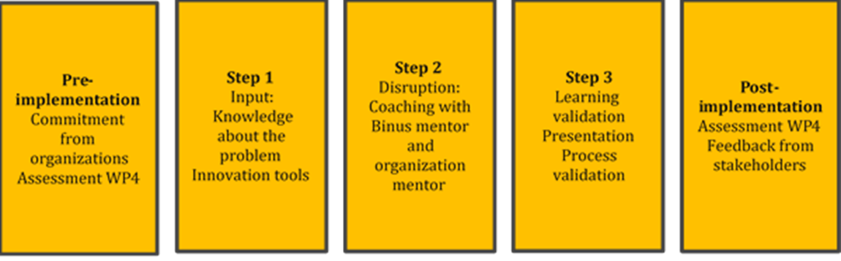

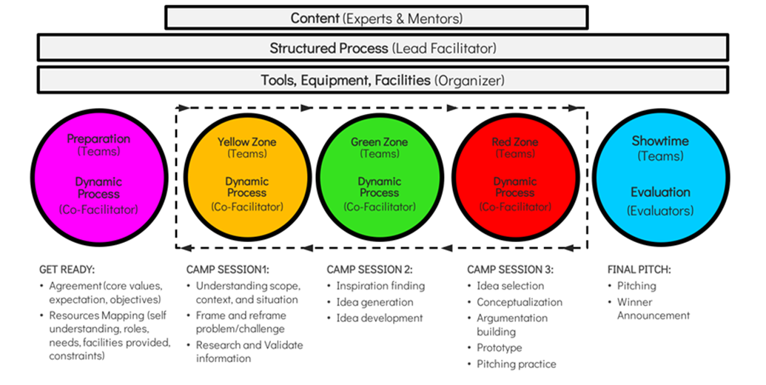
Source: Handrich Kongdro, Binus University.

2. Why Innovation Camps?
Our thesis is that when students participate and actively work in innovation camps, they prepare themselves for the 21 first century labor market. In 2015, The Center of Curriculum Redesign published the book “Four-Dimensional Education: The Competencies Learners Need to Succeed”, which OECD has included in the visions for education 2030. When participating in an Innovation Camp, we believe, that the students actually work in all the four dimensions, and through Innovation Camps, we focus on, at least some of the important six character elements.
Figure 2: Four Dimensional Education
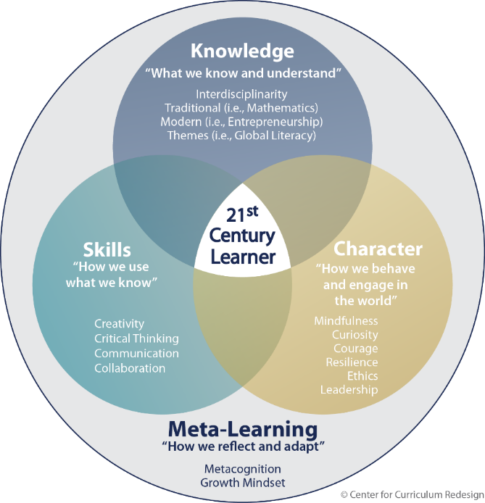

Source: Center for Curriculum Redesign, Charles Fadel, 2015.
Thus, we are preparing students for the 21 first century labor market. They build knowledge, skills and character, although the meta-learning probably not take place immediately after an innovation camp. At Business Academy Aarhus we have learned, that the reflections and meta-learning usually happen in the students latter work and projects, and most often after the students graduate.

The students will also acquire some of the important skills that World Economic Forum in 2016 has predicted for the future world of work in 2020.
Figure 3: Top ten skills
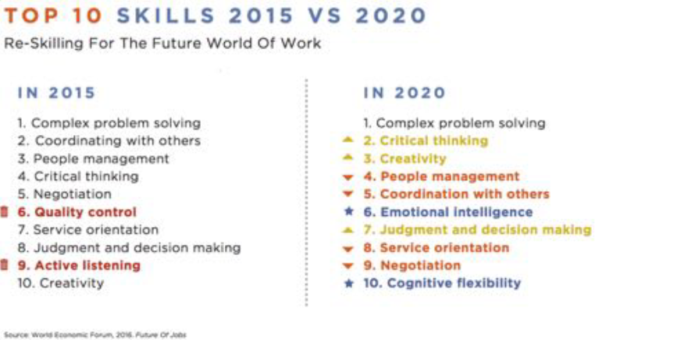
Source: World Economic Forum, 2016.
Through the close collaboration with the business industry and companies in the region, where Business Academy Aarhus is situated, we have specific knowledge from companies and organizations about their expectations to our students’ skills. They expect, demand and value skills in collaboration, teamwork, complex and innovative problem solving, creativity, critical thinking, resilience, curiosity and leadership. This also applies for future education in Indonesia in preparing students for the demands from Indonesian business and organizations.
Implementation at Yogyakarta State University, Yogyakarta and Binus University, Jakarta.
Piloting of the learning method Innovation Camp at Yogyakarta State University (YSU). Responsible lecturers: Svenja Volkert and Tri Sugiarto.
From November 25 – 27 in 2016, the team of YSU conducted an Innovation Camp for the 1st and 3rd semester students from 11 different study programs of the Faculty of Languages and Arts. Seventy students voluntarily signed up and took part in the program. The program took place in a natural campsite environment with wooden huts, just beside a river and not far from Merapi volcano, called Desa Wisata Kembang Arum. Besides the students, who formed twelve interdisciplinary teams, there were the following people present during the program: One process leader, one process coordinator, six lecturers in the role of facilitators, five observers who accompanied the facilitators, two experts and a jury consisting of five people.
The goal of the Innovation Camp was to enable the participants of the camp to present the most possible creative and feasible idea to solve a certain problem faced by business, government, or society in general. In the case for Innovation Camp in YSU, the challenge was:
“How can you create non-monetary incentives for people to reduce, reuse and recycle solid waste in their houses and neighborhoods in Depok, Sleman, and Yogyakarta?”
The challenge was proposed by YSU stakeholders, a staff member of BORDA (= Bremen Overseas Research and Development Association) and then discussed with a staff member of the local government, representing the Kecamatan Depok, Sleman.
The program started with two workshops a few days before the actual Innovation Camp began. One workshop was a preparatory course for the lecturers, who enrolled themselves to take part as facilitators and another workshop was a preparatory class for the students. Both workshops are relatively important for the smooth running of the implementation of Innovation Camp. In the workshop for students, the goal was to equip students with the tools for generating ideas. The workshop introduced them with the three zones principles that enable them to develop and structure their ideas better. The workshop for lecturers was also crucial, because the lecturers needed to have the same perspective and understanding that facilitating was different from lecturing. Thus, as the lecturers received information and training for facilitating the camp, it secured no violation of the nature of fasilitating and the ultimate goal of the camp. Business Academy Aarhus, Denmark, who conducted this program on a regular basis at their own university, led the workshops.
On Friday November 25, after lunchtime, the students departed to to the above-described campsite. There, they were divided into multidisciplinary teams and played some teambuilding activities. The next morning, the teams got the challenge and a period of 4 hours to come up with their two best ideas. The rules were the same for all: All the teams got the same assignment and the same deadline. Therefore, competition mode was on from the very beginning. After the first presentation, the teams got feedback mainly by the other teams and returned to work until night, when they got a detailed feedback from the facilitators in order to improve their findings. The following morning, the teams got the last chance, to present their ideas in front of the facilitators to get some feedback. Just after lunch, the official presentation in front of the jury followed. The jury members were 1) a staff member of the local government, representing the Kecamatan Depok, Sleman (a second stakeholder), 2) two representatives of BORDA as well as 3) two representatives from YSU (Dean of Faculty of Languages and Arts and Head of the International Office). The jury finally determined three winners and delivered the token of appreciation for them.
Table 1 Innovation camp in Yogyakarta (Preparation and Execution)
No. | Day/date | Time | Activities
 | Wednesday, 23 November 2016 | 10:00-15:00 | Workshop with facilitator (and observers)
 | Thursday, 24 November 2016 | 09:30-11:00 | Workshop with students
 |  | 13:00-14:30 | Discussion with facilitator’s team, stakeholders, and committee
 | Friday, 25 November 2016 | 14:00-15:00 | Go to Desa Wisata Kembang Arum
 |  | 15:00-15:30 | Room distribution
 |  | 15:45:17:30 | Team building activity 1
 |  | 17:30-19:30 | Shower, snacking, preparation for the student’s team building 2 and performances
 |  | 19:40-22:00 | Students performances, barbeque, and bonfire
 |  | 23:00 | Sleep
 | Saturday, 26 November 2016 | 07:00-08:00 | Breakfast
 |  | 08:30 | Meeting in the “auditorium” house  The representative from the Office of District of Depok introduce the challenge
 |  | 09:30 | Get to work  Facilitators and observers visit the group (after an hour of working time)
 |  | 14:00 | 1st presentation  Each group presents its two best ideas (max 4 min)  Oral feedback – one group gets the chance to give comments (max 2 min)
Get to Work
Facilitators and observers visit the group (after an hour of working time)
 |  | 19:30 | 2nd Presentation  One group presents max 4 min. Max 4 min feedbackfrom team of facilitators
 |  | 21:30 | Work  Facilitators and observers visit the group (after an hour of working time)
 | Sunday, 27 November 2016 | 07:00-08:00 | Breakfast
 |  | 08:30 | 3rd Presentation  One group presents max 4 min. Max 4 min feedbackfrom team of facilitators
Work
Facilitators and observers visit the group (after an hour of working time)
 |  | 13:00 | Final Presentation
 |  | 14:30 | Announcement of the winner
Source: Tri Sugiarto, M.Hum, Yogyakarta State University.

Piloting of the learning method Innovation Camp at Binus University. Responsible lecturers: Handrich Kongdro and Ina Murwani.
The camp organized by Binus University was a social innovation camp. The content in the Social Innovation Camp was one challenge, two days outdoor work, the three zone (yellow, green, red) tools for the innovation process. The framing of the innovation camp was, that “if inno camp is a kitchen, it will offer “surprising foods”. The ingredients in the Innovation Camp were facilitator team, multidisciplinary students, experts, mentors, organizer, sponsor, challenge, owners. Ninety students participated at five different location, and they came up with sixteen solutions to the challenge.
The program started with two workshops a few days before the actual Innovation Camp began. One workshop was a preparatory course for the lecturers, who enrolled themselves to take part as facilitators and another workshop was a preparatory class for the students. Business Academy Aarhus, Denmark, held the workshops and participated during the innovation camp as facilitators as well.
As an academic partnership, Bina Nusantara University and Business Academy Aarhus have worked together, especially as Innovation Camp facilitator team to optimize students learning experience. Both graduate and undergraduate programs were involved in this pilot. In addition, to reach its objective, Binus University worked with several organizations to introduce real social challenges.

Table 2: Innovation Camp in Jakarta (Preparation and Execution)
Stakeholders | Organizations | Locations | Participants | Activities
Coordinator  Facilitators  Mentors  Panelist  Students | Campaign.com – social networking platform and community for change  Akademi Kompos (Waste Bank) – waste management, social enterprise  Jakarta Hidden Tour – Jakarta urban slums tourism activist  Sanggar Waria Remaja (Swara) – vocation alternative school for transgender  Yayasan Sahabat Anak – education foundation for street kids  Xcidic Singapore – innovative technology lab  DAAI TV – local television which focus on positive broadcast | Urban Poverty Challenge (Jakarta Hidden Tour) https://goo.gl/maps/rxmnQRFwvyv  Transgender Challenge (Swara)  https://goo.gl/o282Qi  Waste Management Challenge https://goo.gl/maps/voMWo3eMBRw  Early Childhood Education Challenge (Sahabat Anak Pasar Rebo)  https://goo.gl/maps/w8AEZ5ZpJ6o  Legal and Empowerment Challenge (Sahabat Anak Grogol) https://goo.gl/maps/TV9hMrcq58q | Graduate/Master Degree Program 95 students, 19 teams.  Participating facilitators:  Handrich Kongdro (BU)  Ina Murwani (BU)  Ahmad Seiichi Ramadhan (BU)  Peri Akbar Manaf (BU)  Valentina Tohang (BU)  Dwita Ulibasa (BU)  Jesper Nørskov (Business Academy Aarhus)  Steen Kamronn (Business Academy Aarhus)  Panelist were chosen from both internal and external stakeholders:  Rini Setiowati (BU)  Sukma Putra (BU)  Artomo (Akademi Kompos)  Ronny Poluan (Jakarta Hidden Tour)  Vina (Sanggar Waria Remaja)  Alles Saragih (Yayasan Sahabat Anak)  Gabriel and Febri (Xcidic Singapore) | 1st Day – Saturday, 8 April 2017  The event started by giving a brief to the students. Rini Setiowati kicked off the program by welcoming them and sharing the new concept and overall objective of this initiative. Handrich Kongdro continued to motivate and introduce how this initiative will give students a valuable experience before taking it to the next level, especially if the students want to build their startup or do social projects. Ina Murwani introduced the method of InnoCamp and told the students, what to do from the beginning until the end of event. Rini Setiowati also gave additional information about the technical briefing of this event on the D-Day.  4 organizations were invited and they presented their challenge in front of all the students, so the students could start thinking on their idea and solution. Before lunchtime, the students were prepared after a non-facilitated activity, to come up with their own solution. After lunchtime, they present it and the result is as expected! They all have almost similar ideas without being facilitated and going to the field.  2nd Day – Friday, 21 April 2017  The next day was also important since it started with a facilitator workshop. Jesper and Steen from Business Academy Aarhus, Denmark, were the main trainers. We agreed on how we will facilitate the 2-day in-campus camp. Jesper and Steen shared the best practices from Denmark and we had a discussion on how to apply it in BINUS context. Besides, all of the materials needed during the event, were reviewed.  3rd Day – Saturday, 22 April 2017  The first day of the camp was successful. It started from registration, breakfast, and t-shirt distribution. After that, the trip was divided into 5 teams to 5 locations. Each of the facilitators gave separate brief during the trip to locations. It was a great time for both students and facilitators to interact with the community because of field insights. After finishing the activities on the field, all headed back to the campus to work on the next stage.  In campus, every team received guidance and facilitation in order to go through the three zone methods, which all facilitators have agreed upon in previous day. It was a dynamic process from afternoon until evening. Students even continued on their work after in-campus session ended. They were preparing the showcase day about their innovation to all of our partner organizations.  4th Day – Sunday, 23 April 2017  In the morning, all the students were still preparing each of their booths while the invited panelists were coming. The committee gave a brief to the panelist and started the assessment after every booth was ready. At the end, the result of panelist assessment was calculated and announced in the closing ceremony.  5 best out of 16 teams were picked out. Before the announcement, all the students gathered in the auditorium to get final debriefing from Jesper Nørskov, Handrich Kongdro, and Rini Setiowati. During the lunch, all participants filled out the self-reflection paper. As a final activity, the committee gathered all of panelist, facilitators and students to announce the winner, gave the appreciation and taking group photos.
Source: Handrich Kongdro, Binus University
3. Evaluation
One of the aims in the INDOPED project and all the innovative pedagogical methods piloted in the project is to increase students’ innovative skills as well as a transformation from Teacher Centered Learning to Student Centered Learning. This is of course present in the purpose of and learnings from implementing innovation camps.
The numerous evaluations from Business Academy Aarhus show, that students perceived the Innovation Camps to give them and increase their skills and competences according to the basic innovation competences shown in the FINCODA Innovation competence model below. They learn to master an innovation process, they learn to handle a team process with difficulties, collaboration and conflicts, and they learn to organize their work and handle time pressure, presentations and feedback. In the qualitative evaluations, they also refer to obtaining and enhancing skills such as curiosity, leadership, resilience and courage.
Figure 4: Innovation Competences
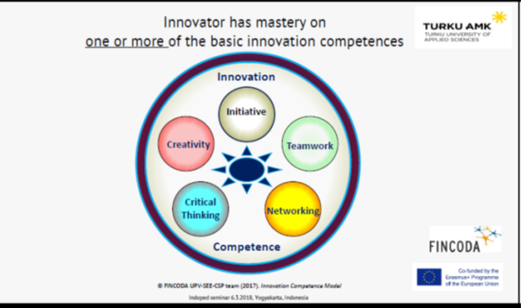
Source: www.fincoda.eu
At Business Academy Aarhus, The Innovators DNA model is an inspiration and a fundament in the entrepreneurship teaching. Several times, after Innovation Camps, students (and facilitators for that matter), realize that the behavioral and cognitive skills in the model, often are exactly the ones demonstrated in Innovation Camps, without knowing the model. So through the qualitative evaluation after a camp and the inclusion of the model in following teaching, the students find, that the actually learnt these skills and is taking a big leap forward into mastering the skills of an innovator.
Figure 5: Innovators DNA
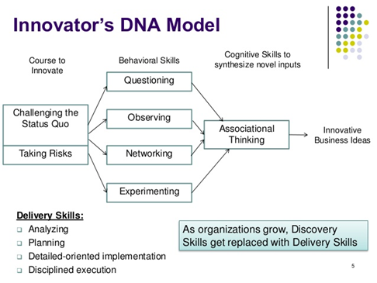

Source: https://hbr.org/2009/12/the-innovators-dna
However, what were the learnings and evaluation of the piloting of the Innovation camp?
4. Evaluations from the participants in the Binus University Social Innovation Camp
“The methods (yellow-green-red zone) help us to get a real surprisingly and unusual solutions. Because we can use one zone to view the problem and another to seek solutions”, ARINA.
“Each respondent gave different responses to our questions. Some were open others only gave limited answer. This situation just opened my perspective. We could not judge the persons from how they looked. They had also skills, same feelings like us and how they feel when they were isolated”, PUTRI.
“So many things we got. It was like revelation from a world that we never got in touch or even we did not want to involve. They were not as negative as we thought. Without this event, we most likely never go there, even to think about it. I could be more empathic”, VEGA.
Overall, the evaluation of pilot of the Innovation Camp at Binus University was positive. The innovation Camp was a success due to positive feedback coming from the stakeholders: Organization partners, students, facilitators, panelist, and the collaborators from Business Academy Aarhus, Denmark. Especially, considering that the event was the first time for Binus University.

During the pilot, stakeholders’ time and schedule was the main challenge especially in the facilitation skills workshop, half of the facilitators could not join the workshop fully due to other schedule and priorities. Different locations and agenda or situation of each organization partners also became a challenge to keep every team in the same pace and structured facilitation. When everyone came back to the campus, classroom locations for each team in different floor also affect the effectiveness of the Innovation Camp process, which gave some delay on delivering next stage.

Besides that, the facilitation process was going smoothly. Even more, the organization partner founded the result of this learning method was really showing a solution they are looking for, which in the same time increased students’ confidence level. Besides, this learning method was also a revelation for some students because they work in “real life cases”.

Interviews, stating the perspective from each stakeholder (facilitators, mentors, and students), also proves the value of the Innovation Camp and supports the general conclusion on the Innovation Camp at Binus University.

“Innovation Camp is an effective learning method for matriculation program to “set the tone” of innovation culture, but not necessarily enough to implement the real solution for organization partner. Therefore, an after event follow-up would be important to make sure the idea continue benefiting organization partner. One of the ways is to continue incorporate it in the courses along the upcoming semester”. Handrich Kongdro.
5. The Innovation Camp in Yogyakarta State University.
The Innovation Camp was a success, because everything worked out very well and everybody learned a lot during these two days. Not only students, but also the lecturers involved in the camp expressed positive evaluations, and that they experienced new things with the method. Some evaluations given by the students were as follow:
“I had a new experience with Innovation Camp. I had to work more than 24 hours with a very sharp deadline. This was crazy for my team and me. Yet in the end, we made it and we were so proud and happy with our result. Personally, the camp improved my communication skills and importantly it made me more disciplined, because I had to manage my time to work with deadline. I believe that people, especially students need this kind of activity to themselves for a successful future”. (Danika, a student from English Education Department)
“Innovation Camp provided me with the strategy to develop ideas step by step and prepare and present things in a systematic way. This method pushed us to produce creative and innovative ideas to solve the problem faced by the society. This also trains us to work in team and time management. My team and I had to show much discipline in order to finish everything based on the time allocated. For me this activity gave me lots of positive outcomes”. (Edita, a student from German Education department)
“Innovation Camp improves my critical and innovative thinking. This also drives me to think fast and effectively because the time is limited. In addition, it trained me to be out from my comfort zone, because I have to work with new people who come from other diciplines. It is not a piece of cake because many times I have different point of view than them, but I have to respect the difference in order to keep on the team’s goal”. (Hilman, a student from Music Education Department).
The aforementioned evaluations showed that the Innovation Camp in YSU indeed provided students with the opportunity to explore and experience many things that did not present itself in the classroom settings or activities. Being able to work in multidisciplinary team would be one among the many positive results of the implementation of the method. Another one is the ability to work with a specific time boundary. This led the students to be diciplined and manage their time effectively. Fail to manage the time, was equal to start ruining the teams’ pride as they were all in a competitive mode and needed to always update their progress every four till six hours work and discussion infront of facilitators .
Furthermore, the method also increased the students’ innovation competence performances, illustrated by the following charts:
Table 3: Self-assessment of innovation competence performance
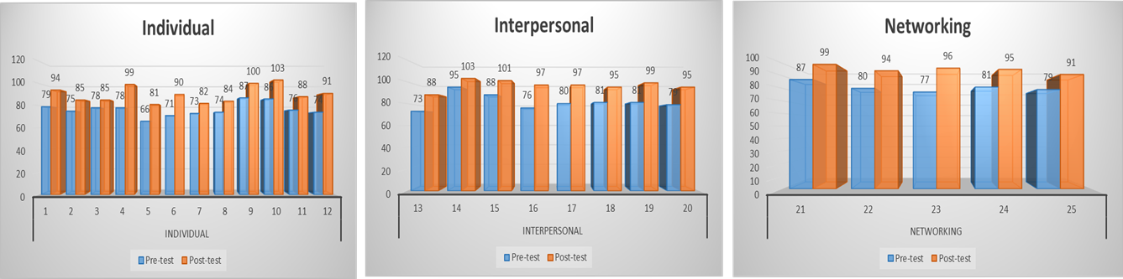
Source: Tri Sugiarto, Yogyakarta State University.

From the pre and post evaluation of the implementation of Innovation Camp in YSU, as it is represented by the above charts, the method improved the Innovation Competences of the students at least in three areas; individual, interpersonal, and networking. For individuals, the method increase the students’ ability to present creative ideas, evaluate and foresee problems and solution from different perspectives, show enthusiasm and focus on the work or task target. For the impact on the interpersonal, the camp improved the ability of the students to transmit ideas to others, to listen and dialogue with teammates, to collaborate effectively, to take initiative, and to be flexible toward conflict. In addition for the networking, Innovation Camp led the students to consider the implication of their thoughts toward society, to work in multidisciplinary teams and multicultural environment, and to use network contacts.
The lecturers, who worked as facilitators in the innovation camp also expressed that the camp benefitted them. The camp channeled them to a new pedagogical approach that inspired them to shift from the traditional teaching approach to the tested one. Most of the lecturers agreed that their teaching strategies were more to direct and instruct, than to facilitate. They could not resist informing students what were the acceptable opinions and what recommendations looked like. They would not listen to irrelevant and unfeasible solutions offered by the students in their teaching routines. Thus, some said that become a facilitator was not a piece of cake at all! The lecturers needed to possess critical and creative way of thinking in the first place. They also had to be open-minded and possess an egaliterian personality.
Other lecturers expressed their appreciation to the implementation of Innovation Camp. They mentioned that the method has trained and led the students to be autonomous learners. They collected data, read, evaluated and discussed them to select the most relevant one to their needs. These would prepare them with sufficient skills to conquer the competitive and challenging society after they finished their undergraduate level.
Two alumni facilitators from the Innovation camp implemented the method in their subjects last semester. They ran an 8 hours camp inside the faculty on the weekend. They adopted the principles of the model such as giving training for both student and facilitator before the implementation, involveing stakeholder from inside and outside of the university and many other preparations, similar to the one previously conducted in YSU. The result of the implementation was also extraordinary, but gave some lessons learnt from this very short camp. The most important one was the fact that the 8 hours would be a very short period to produce thought provoking ideas or solutions. This was too short, as the students have just started to heat after the second presentation and feedback from the team of facilitators, while the presentation was just set three times.
6. Recommendations for planning and implementation of Innovation Camps.
The camp model draws on well-established principles taken from the innovation and entrepreneurship field. This and the two pilots of Innovation Camps in Indonesia, leads to some recommendations.
Prerequisites:
- Diversity - because students are recruited from different disciplines to work with concrete tasks in cross-disciplinary groups. This provide several benefits, such as giving them insight into other disciplines, making them understand their own discipline better, and, not least, resulting in more interesting ideas and innovation results than work in single-disciplinary groups. Second, students work across the important borderline between Academia and business, applying their theoretical knowledge to concrete problems in businesses or NGO’s, meeting and working with people rooted in practice rather than theory.
- Horizontal thinking - Moving across cross curricula fields are well-known drivers in idea generation processes and entrepreneurship. Great ideas are often to be found in the intersection between sectors, domains, disciplines and cultures (Johansson, 2004). Horizontal thinking is particularly important in the early stages of a camp where the minds of participants are open to other knowledge fields and people - and their own fixed positions challenged.
- Parallel thinking - Camp participants work in teams where parallel thinking is important to achieve creative collaboration and coordinated action (De Bono, 1995). Minds tuned on the challenges of the team is important, as participants should do their best to work in the same direction, particularly in the result oriented stages of a camp setting.
- Problem orientation - Problem Based Learning (PBL) is a well-known learning approach and often seen as core to the entrepreneurship-teaching field (Hanke et al., 2005). Departing from a problem rather than a topic changes the rules of the game in the learning process. Knowledge and topics are no longer ‘supplied’ to passive learners, but asked for by active learners who face challenges when trying to solve a problem.
- Action learning - Action is made a key ingredient in the camp learning process. Generally speaking, “doing, thinking and talking” are core ingredients in this type of learning process rather than "listening, reading and memorizing”, (Löbler, 2006, Scharmer & Käufer, 2000). This doing side is consistent with Kolb’s experience based learning circle, suggesting that praxis (or simulated praxis) is core to the learning process (Kolb, 1984).
- Future orientation - Fostering ideas and solving innovation challenges means moving into unknown territory rather than absorbing past and present knowledge. It is about seeing and evaluating a possible future state or solution before it has become reality (Scharmer, 2007).
- Facilitation - The team process needs attention and facilitation. Hence, trained team facilitators monitor the processes and intervene when appropriate, advising the team on how to get across barriers, obstructing the process if ideas fly too low, and easing the psychological atmosphere and physical well-being of the group members in order to maximize collaboration and concentration. Contrasted traditional classroom teaching, the teacher role change to the facilitator role and students converted from passive consumers of existing knowledge to active producers of new knowledge. Lecturers most be trained to become facilitators. In becoming facilitators, lecturers must accept that (students’) creativity works best without their expertise and judgement.
Framing:
- Neutral location, outside university/classroom.
- Involvement of outsiders, collaborate with helpful stakeholders. Helpful to finance the event and to open as many resources and information as possible to solve the given problem.
- Well defined roles for camp organizer, team facilitators and participating students. The appointment of a camp leader is very important, as the camp leader has the responsibility for a dynamic and time pressured process.
- Students have to be split into cross-disciplinary teams, before the Innovation Camp starts.

Process:
- Train the studens with 3 zone tools for the idea generation. This is crucial in order to inform the students how to structure and evaluate their ideas.
- Train the lecturers to be a good facilitators! Facilitating process helps the students with possibles perspectives and thoughts that would open their horizon, yet not dictating! This demands training because not every lecturer is born with such skills.
- The flow are guided by outcome/solution orientation, related to the overall camp goal
- Students should know little about the camp program before they arrive
- The flow should be prepared well and structured in detail
- Facilitators should energize or support/obstruct the process through interventions and exercises
- Time pressure should be tough
- Do the Innovation camp for minimally 48 hours
- Plan the Innovation Camp in the beginning of the semester, so that scheduling and practicalities do not become obstacles.
Considerations:
- How much do the students need to know about the domain of the challenge before the Innovation camp in order to be able to work with the challenge? It is a balance between sufficient knowledge to be able to understand the domain and the context of the challenge, but on the other hand still be able to ask questions and challenge “status quo”. Therefore, consider carefully the need and nice to know information for the students.
- How much time do the camp leader and facilitators place in the 3 zones? There has to be a tight time pressure, but still enough time to work sufficiently in each zone. Therefore, consider and evaluate carefully before and during camp, how much time each zone requires.
- How can an Innovation Camp complement and support the ordinary curricula? Each faculty has several learning objectives to fulfil, but perhaps doing an Innovation Camp could be a shortcut and at the same time a way to raise the learning level accordingly? Consider and evaluate carefully, when, how and why it could be appropriate to include an Innovation Camp as an extra or co-curricular event.
Practicalities:
- Please see the detailed programs from Yogyakarta State University and Binus University.
- A complete and detailed inspiration and guideline to Innovation Camp is available here: www.idea-camp.eu/eu-camp-guide.

7. Conclusion
When the INDOPED project started late 2015, the self-assessment report concluded that there were significant needs for the Indonesian university partners to move from the traditional teacher-centered learning (TLC) to student-centered learning (SLC). The prevailing perception of all INDOPED partner universities was that The SCL is the better method to engage students actively in their learning. The internal concern was at that point, how to change the mindset (attitude) of administrators, lecturers, and students. The necessary change should be directed toward putting the students at the center of the learning process, the lecturers as the facilitators of the process, and the administrators as the provider of sufficient learning supports. Therefore, the recommendation was a need for good training and intensive mentoring from European university partners. In addition, the report pointed at a current wide gap between academics and industry.
The two pilots of Innovation Camp have proven to, in many ways, to meet and correct the needs and assumed difficulties pinpointed in the self-assessment report. The evaluations of the two Innovation Camps show, that students CAN be the center of their own learning, and that they gain skills and competences in the field of innovation and entrepreneurship, which are valued highly by industry and recommended by all learning authorities as important for succeeding in the 21 first century labor market. They also show that lecturers CAN manage and value the transformation from teacher-centered learning, they can become facilitators and promote the student centered learning. One of the most important factors in the concept of the Innovation Camps is collaboration between academics and industry. This also applied for the pilots and the experience for both parties were indeed positive. The training and intensive mentoring from the European university partner was in place, but so was the careful, engaged and motivated planning, implementing and execution from the two Indonesian university partners. All points to the importance of a good and close collaboration between the the European and Indonesian partners in order to obtain a valuable learning and implementation of an innovation pedagogy, from which students, lecturers, educational students and the Indonesian society benefit.

References:
Blom, U. H., 2005. Guide til afholdelse af en innovation camp. IDEA/Videncenter Vest.
De Bono, E., 1968. New Think. The use of lateral thinking in the generation of new ideas. New York: Basics.
De Bono, E., 1995. Parallel Thinking. From Socratic thinking to De Bono thinking. London: Penguin Books.
EU Expert Group, 2008. Entrepreneurship in higher education, especially within non-business studies. EU Commission: Enterprise and industry.
Gibb, A., 2006. Towards the entrepreneurial university. Entrepreneurship education as a lever for change. Birmingham: NCGE Policy Paper Series.
Gibbons, M. et al., 1994. The New Production of Knowledge. The Dynamics of Science and Research in Contemporary Societies. London: Sage.
Hanke, R., E. Kisenwether, A. Warren, 2005. A scalable problem-based learning system for entrepreneurship education. Academy of Management Best Paper Proceedings 2005.
Hansen, S., C. Byrge, 2007. Den kreative platform (the creative platform). Kreativitetslaboratoriet, Aalborg University: Aalborg.
Johansson, F., 2004. The Medici Effect. Harvard Business School Press
Kolb, D.A., 1984. Experiential Learning: Experience as the Source of Learning and Development.
Bager, T., 2009. The Camp Model for Entrepreneurship Teaching. IDEA, Southern University of Denmark: Kolding.
Hutagaol, Y. R., Adiningrum, T. S., Budiono, T. A., Kongdro, H., Ramadhan, A. S., Putra, S., Fibra, A., 2015. Binus University. Self-assessment report, INDOPED project.
Fadel, C., Bialik, M., Trilling, B., 2015. Four-Dimensional Education: The Competencies Learners Need to Succeed. Dafolo: Denmark.
Gregersen, H. B., Christensen, C. M., Dyer, J., 2009. The Innovator's DNA - Mastering the Five Skills of Disruptive Innovators. HBR.
Websites – visited during October 2018.
www.curriculumredesign.org
www.curriculumredesign.org/our-work/four-dimensional-21st-century-education-learning-competencies-future-2030
www.fincoda.eu
www.weforum.org/agenda/2016/01/the-10-skills-you-need-to-thrive-in-the-fourth-industrial-revolution
www.baaa.dk
www.idea-denmark.dk
www.binus.edu
www.english.uny.ac.id

