5-5-5: A teaching practice exercise rooted in the effectuation principles
Susanne Østergaard Olsen
Business Academy Aarhus, Sønderhøj 30, 8260 Viby J, Denmark.
E-mail: suol@eaaa.dk
Jesper Nørskov
Business Academy Aarhus, Sønderhøj 30, 8260 Viby J, Denmark.
E-mail: noje@eaaa.dk
Abstract
The perspective of this 3-pager on 5-5-5 is practical and empirically based, with the purpose of describing and discussing how Business Academy Aarhus have tried to apply the effectuation principles in a practical learning context. The 3-pager covers the rationale and motivation for translating the effectuation principles into a very practical and concrete learning exercise and experience, focusing on the what, why and how (implementation) of a mandatory assignment, called 5-5-5, for students attending the Bachelor Program in Innovation and Entrepreneurship at Business Academy Aarhus. The description of 5-5-5 and our gained experiences will lead to points for discussion concerning the implications on implementation of the effectuation principles in a practical learning context.
Keywords
Effectuation; innovation; pedagogical methods; entrepreneurship; student driven learning.
May 2019

1. Introduction
Business Academy Aarhus is one of the largest business academies in Denmark. We develop and offer practice-orientated higher education programs primarily for the private business sector, and our main goal is to enable students to get a job. We have 4900 full-time students, 700 international students and 430 employees. Business Academy Aarhus is a University of Applied Sciences. Like research universities, we provide undergraduate programs and can grant academic degrees, but we do not award masters or doctoral degrees. In addition to this, we also offer further education and part-time program up to Bachelor’s level for people who need to strengthen their qualifications on the job. Our wide range of full-time higher education program qualify students for many different career choices within these fields: Business, IT and Technology, Web, Media and Communication, Environment and Agriculture, Biotechnical and Food Technology and Finance.
Our programs combine theory with practice, as we prioritize small classes, group work, project work, cooperation with trade and industry, realistic cases and compulsory internships. Through our close collaboration with the business community, we learn and benefit from one another.
According to this, the fundament in Business Academy Aarhus’ pedagogical platform is "close to practice", meaning, that the industry context, which students must work in, after graduation, is the starting point for all pedagogy. The core value is “Insight provides perspectives, only action brings true transformation”. Learning at Business Academy Aarhus is student centered, (SCL) and teaching is a dynamic, interactive process with emphasis on active student participation. This is especially important in a Bachelor program in Innovation and entrepreneurship, because we wish to motivate and guide our students, right from the beginning of their education and journey against a career as either entrepreneur or intrapreneur. Consequently, the very first mandatory assignment, the students meet at the Innovation and Entrepreneurship bachelor program, is 5-5-5.

2. What is 5-5-5?
The table below contains the presentation of the assignment for the students.
Five students – Five days – Five hundred DKK

Task

During the next week (five days) your task is - in groups (five persons) - to earn as much money as possible with a start capital of 500 DKK. Use your imagination to come up with all kinds of possibilities to make your money grow.
There are no limits except the laws and ethics of Denmark :o) Your activities MUST take place outside of the premises of the academy!

Daily Reflections
Throughout the week, you must record your actions and how you solve the week’s challenges as a group (be specific). Use the dairy template uploaded in Canvas (week 36) to do so and e-mail the dairy to the specified lecturer no later than 8 am Friday 7 September.

Output
Friday 7 September you are to do a plenary presentation of your week’s work (max 5 minutes) containing the following:
- What was your goal?
- What did you do?
- How did it go? In addition, Why?
- How was your teamwork? What went well and less well?
- What profit did you make? Is there a business potential?

You must return the 500 DKK Friday 7 September via Mobile Pay to Head of Education, tel. 20142831.
Any surplus you can keep for the team!

Time plan

- Monday 3 September at 08.30: Kick off at the Innovatorium.
- Friday 7 September at 09.00 – 14.00: Presentation at the Innovatorium (all groups). After the presentation, we select an overall winner based on the ability to execution and results.

SOS
If you need to get in contact with your lecturers find contact information and contact hours at Canvas week 36.

3. Why 5-5-5 and how?
The reason why, Business Academy Aarhus include activities as 5-5-5 and Innovation Camps is that it is an accurate implementation of the teaching principles, following the overall pedagogical and educational platform at the Academy. In addition, it is an efficient mean to give the students skills, which enable them to succeed in a dynamic, ever-changing 21st century working place, whatever they pursue a career as an employee (intrapreneur) or an entrepreneur. The purpose of using the Effectuation principles for designing a practical learning exercise, besides the perfect match to our pedagogical platform and the overall learning objectives in the Innovation and Entrepreneurship Bachelor Program, is that, effectuation is a logic of thinking that uniquely serves entrepreneurs in starting businesses. It provides a way to handle a future, which is inherently unpredictable.
However, we do not tell the students, when we start the 5-5-5 assignment, that the theoretical fundament for the practical learning exercise is Sarasvathy’s principles for effectuation.
Nevertheless, we strongly believe and have experienced, that in order to solve the 5-5-5 assignment, it require, that the students use most of the principles to achieve a valuable process and good results.
- When the students set out to solve the 5-5-5 assignment, we experience, that they can only start with their means: Who I am, what do I know, and whom I know.

- Then, as future entrepreneurs, they imagine possibilities for making money, which originate from their means including the 500 kr.

- They try to limit risk by understanding what they can afford to lose at each step. Actually, in this case, they only loose “face” in the matter of not being able to make the 500 DKK grow into more money.

- They choose small, seemingly realistic goals and actions where there is an upside, at least valuable learnings, even if the downside ends up happening.

- They seek partnerships with important stakeholders and people from their own network, who increases the probability of succeeding the task and realizing a profit.

- By focusing on relative ambitious, but still small-scale activities within their control, the students try to be the pilot in their own plane and do everything they can to secure, that their actions will result in the desired outcomes.

The intended results of the method leads to the purpose and learning objectives of the 5-5-5 Effectuation assignment, which is to achieve, that the student:
- Acquires the necessary knowledge, skills and competences to manage, execute and handle an effectuation (start-up) process, although in a small-scale attempt. Thereby achieving the competences required to effect, organize and manage a project or event, unconsciously relying on relevant theories and principles such as effectuation and project models.
- Acquires knowledge about network.
- Demonstrates the ability to identify and apply personal resources and network resources and competences in relation to mapping of a business-/event opportunities, which leads to a successful and valuable 5-5-5 process and results.
- Identify ideas, specific project options, and moneymaking opportunities.
- Structure the planning and implementation of a project and/or an event based on the effectuation principles and project management tools
- Define and realize objectives and success criteria.
- Identify and apply personal resources and network resources and competences in relation to the development of an idea and/or a concept and the implementation of a project and/or an event.
- Communicate and discuss the process and outcome of the project and/or event in a report and present relevant videos or image sequences from the actual realization of the project and/or event.
Even though, we do not introduce the students to the effectuation principles and the relation to successful entrepreneurship before the 5-5-5 assignment, we can observe and experience in the students’ work and own reflections after the 5-5-5 assignment, that they really do use the principles. We ask them to evaluate during and after the 5 days in this evaluation diary.
The presentation of their work, process, results and achievements during the 5 days, together with the reflections and evaluations in the evaluation diary, is the fundament and serves as the platform for the following lessons in effectuation. Here we introduce the students to Sarasvathy’s theories, models and effectuation principles, and in this way, we frame the empirical 5-5-5 assignment, experiences, result, process and reflections in the theoretical context. The students realize that they have used and learned the effectuation principles, and they now have empirical and practical learning experiences to relate to the theoretical framework of effectuation.
When the 5-5-5 assignment is truly successful, it is of the basis of a divergent, flexible and collaborative team, which quickly establish trust in each other; they are on the same page in regards to getting along, getting ahead and getting aligned. Usually the team wish to stay together after the 5-5-5 assignment. They used the effectuation principles, unaware of them though, to create an idea, event, product or concept, they can sell in order to make a profit out of the initial 500 kr., and they have a smooth process and fun, while doing so. We have examples of teams who have achieved to multiply the initial 500 DKK with 25-35 times.

4. Purpose in a higher context
One of the aims in the 5-5-5 assignment, and in all the innovative pedagogical methods applied at Business Academy Aarhus, is to increase students’ innovative skills as well as stressing the Student Centered Learning. We strive to give and increase student’s skills and competences according to the basic innovation competences shown in the FINCODA Innovation competence model below. During the 5-5-5 assignment, they learn to master an innovation and effectuation process in a small scale, yes, but still, and they definitely learn to handle a team process with difficulties, collaboration and conflicts. They also learn to organize their work and handle time pressure, presentations and feedback. In the qualitative evaluations, they also refer to needing, obtaining and enhancing skills such as curiosity, leadership, resilience and courage.

Figure 1: Innovation Competences
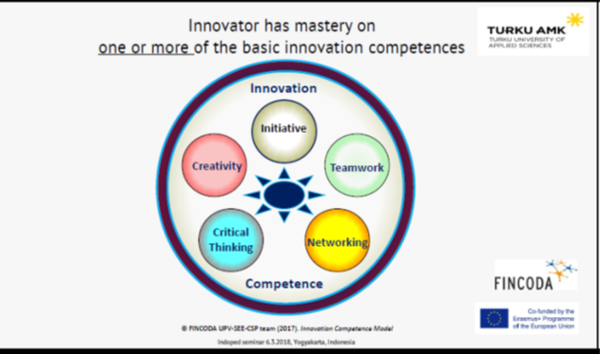
Source: www.fincoda.eu
We also have The Innovators DNA model as an inspiration and a fundament in the entrepreneurship teaching. Several times, after assignments as 5-5-5 and Innovation Camps, students (and facilitators for that matter), realize that the behavioral and cognitive skills in the model, often are exactly the ones demonstrated in those exercise, without knowing the model or principles like effectuation. So through the reflections and evaluation diary after the 5-5-5 assignment or an innovation camp and including and applying the effectuation principles and the model in the following teaching lessons, the students find, that the actually learnt these skills and they are taking a big leap forward into mastering the skills of an innovator.
Figure 2: Innovators DNA
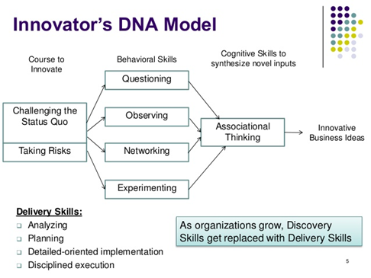

Source: https://hbr.org/2009/12/the-innovators-dna

5. Discussion
Our experiences with the 5-5-5 assignment and the students’ results, reflections and evaluations of 5-5-5 show, that students CAN be the center of their own learning. They gain skills and competences in the field of effectuation and entrepreneurship, which are valued highly by industry and recommended by all learning authorities as important for succeeding in the 21 first century labor market, either as an intrapreneur in established companies or as an entrepreneur starting your own company. What may be points of discussion here, on the basis our experiences, are:
- Is the 5-5-5 assignment applicable for all educational levels?

- Is the 5-5-5 assignment applicable for all educational fields?

- What practical and theoretical advantages and disadvantages does the 5-5-5 assignment have?

- Would the process and results of the assignment improve, if the students were introduced to the effectuation principles before the actual assignment?

- Would the process and results of the assignment improve, if the students were to participate in a one-day workshop in training and facilitating teamwork and team processes?

- Further improvements or discussion points?

References:
De Bono, E., 1968. New Think. The use of lateral thinking in the generation of new ideas. New York: Basics.
De Bono, E., 1995. Parallel Thinking. From Socratic thinking to De Bono thinking. London: Penguin Books.
EU Expert Group, 2008. Entrepreneurship in higher education, especially within non-business studies. EU Commission: Enterprise and industry.
Fadel, C., Bialik, M., Trilling, B., 2015. Four-Dimensional Education: The Competencies Learners Need to Succeed. Dafolo: Denmark.
Gibb, A., 2006. Towards the entrepreneurial university. Entrepreneurship education as a lever for change. Birmingham: NCGE Policy Paper Series.
Gibbons, M. et al., 1994. The New Production of Knowledge. The Dynamics of Science and Research in Contemporary Societies. London: Sage.
Gregersen, H. B., Christensen, C. M., Dyer, J., 2009. The Innovator's DNA - Mastering the Five Skills of Disruptive Innovators. HBR.
Hanke, R., E. Kisenwether, A. Warren, 2005. A scalable problem-based learning system for entrepreneurship education. Academy of Management Best Paper Proceedings 2005.
Johansson, F., 2004. The Medici Effect. Harvard Business School Press
Kolb, D.A., 1984. Experiential Learning: Experience as the Source of Learning and Development.
Sarasvathy, D. Saras, 2009. Effectuation - Elements of Entrepreneurial Expertise. New Horizons in Entrepreneurship Series
Sarasvathy, D. Saras. What makes entrepreneurs entrepreneurial? The Darden Graduate School of Business Administration University of Virginia
Sarasvathy, S., Read, S., Dew, N., Wiltbank, R. 2016. Effectual Entrepreneurship. Taylor and Francis
Websites – visited during April/May 2019:
www.baaa.dk
www.curriculumredesign.org
www.curriculumredesign.org/our-work/four-dimensional-21st-century-education-learning-competencies-future-2030
www.fincoda.eu
https://innovation.sites.ku.dk/model/sarasvathy/
www.weforum.org/agenda/2016/01/the-10-skills-you-need-to-thrive-in-the-fourth-industrial-revolution

