Tangible tooling and design methods as relationship-forming catalyst
in complex npd projects

Trine Graungaard Hjerrild Thomsen & Lisbeth Brøde Jepsen
Business Academy South West (BASW), Denmark
tgt@easv.dk, lbj@easv.dk

Abstract

This research argues for the importance of tangible tools (TT) and design methods (DM) as key instruments for forming inter-organisational relationships in new product development (NPD) projects. But how can DM and TT create trust and strenghen the inter-organisation relationship between supplier and customer? The empirical background for this research is qualitative in-depth interviews with 8 employees from a innovative company producing expanded polystyrene products, anthropological observations of NPD projects and 3 experts interviews (representing two firms and a knowledge institute). The results lead to the following three contributions. First, the use of DM and TT promotes visual behaviour that makes the customer feel more comfortable in decision-making during the during the early idea generation phase of the NPD project. Second, DM and TT minimizes the mistakes and failure during the concept development phase. Last, the utilization of DM and TT is particular relevant for the development of complex NPD projects.

Keywords: Tangible tools & design methods, complex NPD projects & inter-organisational relationship

Theoretical and Relevance and Empirical Background
This research will build on the literature of co-design with specific focus on TT and DM instruments (Brandt, 2011; Ramaswamy et al., 2010; Sanders, 2000; Mattelmäki, 2006; Sanders, 1999; Spina et al., 2002;) for forming relationship with partners in inter-organisational relationship (Ritter et al., 2003) for new product development (NPD) projects. Research has shown that tooling within co-design combined with relationship management foster competitive advantages for suppliers (Bang et al., 2013; Binder et al., 2005) that is necessary for the productivity and survival of suppliers.
The use of TT and DM in NPD requires close collaboration between customer and supplier e.g. every transaction implies information and coordination about customer specific needs and is based on a direct communication between the customer and supplier (Piller et al., 2003). During this process the use of DM and TT have been studied (Sanders et al., 2008). Kolb (2005) focus on the understanding of how actions can create reflection and motivation for new experiments and learning (Kolb, 2005). Sanders & Chan (2007) discuss generative design research where non-designers have the possibility to express their latent needs through tangible tools. This way suppliers can by the utilisation of new development methods and alternative approaches think beyond their own organization and create new ways of develop products together with their customers (Ritter et al., 2003). Furthermore, Martin (2009) argues that design thinking, an interative approach to problem solving and processes, only occur with the mix of analytical and intuitive thinking. An implenmentation of this mind-set in the organisation can transform the suppliers from being customer fitters, a supplier who takes orders from the customer and fulfills the need, to customer developers, where the supplier in union with the customer develops a new product or service (Bang et al., 2012).
Much attention has focused on how, when and what TT and DM are utilized in new product developments (Mortara et al., 2014), but no empirical research has been conducted to validate these techniques in terms of relationship-forming. One of the underlying issues is that the understanding of the concepts: “tangible tools and design methods” is not clear. Past attempts to provide definitions show inconsistemcies and disagreement. The tools range from those which aim to improve informations capturing and processing (Maier et al., 2013) to those intended to be a foundation for coordination, knowledge exchange and control (Bang et al., 2013). The primary focus of this research will be on prototyping or mock-ups as DM or TT.
In order to explore DM and TT in inter-organisational NPD projects, we identified and selected a leading designer and manufacturer of moulded EPS (flamingo): Styropack A/S. This company produces a wide range of items ranging from protective packaging, trays, safety helmets to components for the automotive sector.

Research objective
The objective of this paper is to explore, discuss and evaluate how suppliers can form trusting and strong relationship with their costumers by using design methods and tangible tooling in NPD project? Our focus will be on suppliers’ utilization of different DM and TT during the early idea generation and concept development phase of the NPD project.

Research design
This study is based on an explorative single case study which is a powerful way to elaborate on theory. Semi-structured interviews with four employees at Styropack A/S (the Development Manager, the Sales and marketing manager and two 2 salesmen) as well as a focus group interview with four employees from the development department were conducted. DM and TT (Mattelmäki, 2006; Friis et al., 2009 and Kumar, 2013) were set up and included in the interview to get an understanding the possibilities of relationship formation through DM and TT during co-design (Friis et al., 2009; Kumar, 2013) as well as an understanding of the companys’ use and acceptance of design thinking in a management discoures (Johansson-Sköldberg, 2013). Furthermore, we made anthropological observations of NPD projects and conducted some explorative interviews with experts representing analytical thinking from the company LM Wind Power A/S, experts representing design thinking from Danfoss A/S, and finally some experts representing intuitive thinking from the Design School in Kolding, Denmark.

Results
Our results indicates that the most optimal context for DM and TT is when a company uses tooling in closed participation within a flat governance described as a Consortium collaboration (Pisano et al., 2008). The reason being that the supplier and customer needs loyalty, credibility, security and a verifiable relation to share, discussed and developed trade secrets.
Our primarily results show that the company Styropack utilize mock-up prototyping as a tangible tool in 50% of all the NPD project (Development manager). From the focus group interview we learn that Styropack utilize mock-ups for two main reasons: (1) as a customer test, and (2) for a concept development test. The advandtages of mock-ups is that: ”…it becomes tangible” (Development manager). He further argue that ”The customer can get a sense of the product” and determine: “…whether it works or not”. The findings show that when the parties meet in person and use design thinking when trust is build. As argued: “We have a showroom (with mock-ups), where we have the possibility to show what we can do” (Salesman I) and supplemented by Sales and marketing manager: “There are many things that we do to create confidence and security in the relationship”.
But so-called “drop-test” and “pack-test” are also possible to carry out during the concept development phase (focus group). A 3D drawing can easily indicate that it is possible to pack various components, whereas the mock-up imidiately will show whether this is the case or not (focus group).
We further find that the utilization of mock-up depend on the complexity of the NPD project: “In a long duration NPD project with a lot dialogue … it gets complicated” (Development Manager). In very complicated cases Styropack produces two mock-ups (Salesman II). In other words, DM and TT are especially relevant for the development of technically complex products.
In sum the results indicate that the use of TT and DM; (1) strengthen the relationship with new customer, (2) make tests and evaluations of products during the concept development is possible, and (3) are very important for the development of complex NPD project (see figure 1 for illustration). In case of a cooporation within a standard product the relationship will be eksplicit and make use of say (Sanders & Dandavate, 1999) - low use af TT and DM. The use of make is necessary to express the latent need of a technically complex product with a newly established relationship which results in a greater use of TT and DM.
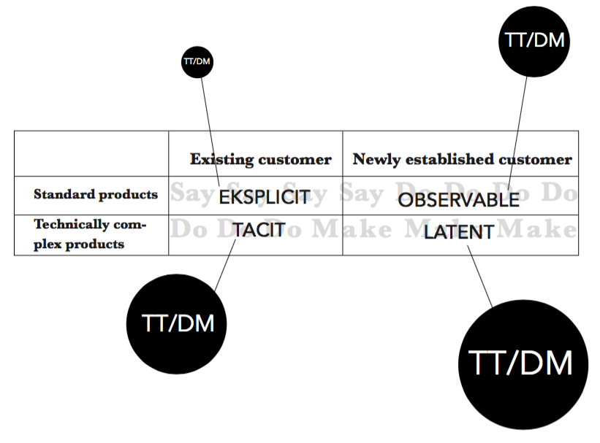
Figure 2. Illustration of how tangible tools (TT) and design methods (DM)
are utilized dependend on type of product (inspired by Sanders et al., 1999).

(Expected) Contribution
We expect to find further evidence on how suppliers can form trusting and strong relationship with their costumers by using tooling in the process of developing complex NPD projects. Our research can therefore contribute to research and pratical implications with knowledge on how DM and TT can facilitate cooperation and consensus regarding complex NPD projects. Whereby, the relationship between supplier and customer will be strengthened, add value to the company (Mozota, 2006), and improve financial returns (Petersen et al., 2005).

Limitations and implications for further research
The customers of Styropack is also highly relevant for our investigation. For future research we have therefore invited the largest customer Vestfrost Solutions (producer of refrigerators and freezers) to engage in an in-depth study on tooling during innovation and its effect on the relationship formation between a supplier and customer.
The next step will be to identify other inter-organisational cases from the same industry utilizing tooling in NPD projects. This way we will be able to conduct a comparable multiple case study, which is a powerful way to elaborate on theory because they permit replication and extension between individual cases (Eisenhardt, 1989).

References
Mortara, L; Phaal, R; Kerr, C; Farrukh, D.(2014). Tool Fingerprinting: Characterising Management Tools. 2014 Proceedings of PICMET '14: Infrastructure and Service Integration.
Bang, Anne Louise & Christensen, Poul R. (2013). Co-creation in distributed value creation systemand networks, Proceedings of the 10th EAD International Design Conference: Crafting the Future, Gothenburg, Sweden 16.-19. april 2013.
Brandt, E. (2011), Participation through Exploratory Design Games, Facilitating Change – using interactive methods, kap. 8, s. 213-253.
Binder, T., & Hellström, M. (eds.) (2005). Design Spaces. Finland: Edita Publishing Ltd, IT Press.
De Witt, Bob & Meyer, Ron (2005), Strategy Synthesis: Resolving Strategy Paradoxes to Create Competitive Advantage, Hampshire: Cengage Learning EMEA.
Eisenhardt, K. M. (1989). Building theories from case study research. Academy of management review, 14(4), 532-550.
Frank, P., Berger, C, Moeslein, Kathrin, Reich, R. (2003). Co-Designing the customer interface: Learning from exploratory research.
Friis, Silje Kamille & Gelting, Anne Kathrine G. (2011), Designskolen Koldings metodekort.
Johansson-Sköldberg, Ulla, Woodilla, Jill & Cetinkaya, Mehves (2013), Design Thinking: Past, Present and Possible Futures, Creativity and Innovation Management, Vol 22 No 2. 121-146
Kolb, Davis A. (2005), Experimental learning: experience as the source of learning and development, netudgivelse Prentice Hall, URL.
Kumar, Vijay (2013), 101 Design Methods: A Structured Approach for Driving Innovation in Your Organization, John Wiley & Sons, Inc. Hoboken, New Jersey.
Martin, Roger (2009); The design of business. 1. oplag, 2. udgave, Harward
Business Press: USA.
Mattelmäki, T. (2006). Design Probes. Helsinki: University of Art and Design Helsinki. PhD-thesis.
Mozotas, Birgitte Borja de (2006), The four Powers of Design: A Value Model
in Design Management, Universitet i Paris, Design Management Institute, Design Management Review, Vol. 17 No. 2.
Petersen, K. J., Handfield R. B. & Ragatz G. L. (2005), Supplier integration into new product development: coordinating product, process and supply chain design, Journal of Operations Management 23 (2005) 371–388
Piller, F. (2003). Mass customization, 3rd ed., Wiesbaden: Gabler 2003.
Pisano, G. & Verganti, R. (2008), Which kind of collaboration is right for you?, Harvard Business Review, Harvard Business Publishing
Ramaswamy, V. & Gouillart, F. (2010), The Power of Co-creation. New York: Free Press.
Ritter, T. and Gemünden, H. G. (2003) Network competence: Its impact on innovation success and its antecedents. Journal of Business Research, Vol. 56, No. 9, pp. 691–697
Sanders, E. B. N. & Dandavate, U. (1999), Design for experiencing New Tools, Overbeeke, C. & Hekkert, O. Proceedings of the rst international conference on design & emotion. Delft, 3.-5. november 1999.
Sanders, E. (2000). Generative Tools for CoDesigning. In: Scrivener, S., Ball, L. & Woodcock, A. (eds.) Collaborative Design – Proceedings of CoDesigning 2000. Springer-Verlag. London Limited.
Sanders, E. B. N. & Stappers, P. J. (2008), Co-creation and the new landscape of design. Co-Design, 4(1), s. 5-18.
Spina, G., Verganti, R. and Zotteri, G. (2002), Factors influencing co-design adoption: drivers and internal consistency, International Journal of Operations & Production Management, Vol. 22 No. 12, pp. 1354-66.

