Developing Multi Business Model Innovation Competence and Environments - an experiment in 8 Nordic businesses

Name Surname *
Peter Lindgren*
Department of Business and Technology
Aarhus University.
Birk Centerpark 15,
DK-7400 Herning
Danmark
E-mail: peterli@btech.au.dk
* Corresponding author

Trine Bjørn Olsen
Department of Business and Technology
Aarhus University.
Birk Centerpark 15,
DK-7400 Herning
Danmark
E-mail: trbjol@btech.au.dk

Klaus Lomborg Nielsen
Erhvervsakademi MidtVest
Gl. Landevej 10,
DK-7400 Herning
Danmark
E-mail: kln@eamv.dk

Michael Niels Sjørvad
Erhvervsakademi MidtVest
Gl. Landevej 10,
DK-7400 Herning
Danmark
E-mail: msj@eamv.dk

Lasse Eberhart Skov
Erhvervsakademi MidtVest
Gl. Landevej 10,
DK-7400 Herning
Danmark
E-mail: lsk@eamv.dk

Klemen Nielsen
Erhvervsakademi MidtVest
Gl. Landevej 10,
DK-7400 Herning
Danmark
E-mail: ksn@eamv.dk

Margrethe Elise Børsting
Erhvervsakademi MidtVest
Gl. Landevej 10,
DK-7400 Herning
Danmark
E-mail: meb@eamv.dk

Abstract

Developing Multi Business Model Innovation (MBMI) Competences becomes more and more important to businesses to survive and compete in the global business model ecosystems. Continuous joint action and knowledge sharing with high speed are fundamental aspects of MBMI for businesses to meet the very complex MBMI agenda of today. Universities and Vocational Schools have a special task here to teach and train students to adapt and develop MBMI competences that can meet these challenges and evolving MBMI conditions, as these young students will be the “Business Modellist” of tomorrow. Further we have to acknowledge that these young students bring in potentially new ideas and “new eyes” to how AS IS Business Models can be changes and How TO BE Business Models can be created, as the students are “born” with the new technologies, media´s and use of these.

However the knowledge about How to do BMI? and How to build BMI Competences? are still important but very fragmented researched, tested, analysed and reported.

The paper reports on 2 experiments in CGC/MBIT research center carried out with 8 businesses (6 Danish, 1 Norwegian and 1 Swedish Business), 32 vocational, master and PhD students and 6 MBMI coaches. The actors worked close together with business management on different Business Model Innovation Challenges with the aim of creating and capturing “TO BE” BM´s. The research was carried out within the project Strategy Reborn and EU Interreg. Project Biogas 2020 and was carried out on behalf of a common accepted BM Language enabling the actors to talk MBMI in the same language with each other.

Keywords – Multi Business Model Innovation, Knowledge creation and capturing, Multi Business Model Innovation Competences, Learning

Paper: Academic Research Paper / Practical Paper

1.0 Introduction

The paper aims at filling in a research gap on Multi Business Model Innovation (MBMI) science and knowledge creation, capturing, delivering, receiving and consumption in the domain of MBMI joint action, coopetition (Nalebuff 1996) and sharing values (Amidon 2005, Porter 2011) in MBMI projects.
The MBMI processes and adaption of MBMI knowledge in the different MBMI challenges were in special focus together with the businesses and students wellbeing and development of MBMI competence.

The paper reports on

- task co-representation (the ability to form and continually build on a mental representation of co-actor’s task in the BMI projects that is going to operated with the MBMI challenge)
- Joint attention (the ability to attend to a new MBMI tasks, knowledge or events created together during the establishment and evolvement of the MBMI project).
- Learning (the ability to learn better with group members and close together with businesses in MBMI project) – supported by physical MBMI tools and a common MBMI language.

The above mentioned focus are regarded to be critical for joint action (Sebanz, 2006) – in our sense MBMI - and thereby has to be addressed and paid attention to when developing new MBMI competence

Some of these topics – as this papers results are a part of a longitudinal study –has been in focus in earlier research presented in different papers (Lindgren 2015), (Lindgren 2016), (Flarup 2017), (Lindgren 2017). The study aims as coming closer to the understanding of the MBMI process and MBMI Competence development. In this case and at the same time, the participants “wellbeing”, learning and “ mood” in the MBMI Process together with the impact of the MBMI environment have been of interest. In one of the experiments - including 3 out of the 8 MBMI cases reported in this paper - we investigated further via an advanced sensor and wireless technology setup in special MBMI testbeds (B-labs/B-cubes) the participants wellbeing (puls and “moode”) and the BMI environments in relation to CO2, temperature, pressure and humidity.

To introduce the overall setup and aim of the research we briefly present how it was original formulated to be:

To create “A Sensing Business Model” and ”A sensing Multi Business Model Innovation environment”. In this perspective
The first objective was to create a generic concept of a “Multi Business Model Innovation ROOM” firstly via creating the concept and prototypes of the object to be in the room – the generic sensing business model – which can take any form necessary or intended by the business in focus. Which can be “cloned” and “replicated” like a “BM cube” with related 7 BM dimensions” (Lindgren and Horn Rasmussen 2013, Lindgren 2014)

The second objective was to create the “The Sensing Multi Business Model Innovation Room” – to build the concept and prototypes of the Sensing MBMI room or lab - in which multi BMI could take place and BM´s could “meet” other BM´s independent of time and place.

These objectives have been worked with since 2014 and several experiments have taken place. However the approach have been to firstly build physical prototypes of the BM Cube, MBMI rooms and then embedded them with sensors attached to advanced sensor technologies that can adapt the large amount of tangible and intangible data from the business models, business model creation and business model innovation process.

In this perspective several experiments with actors using the physical MBMI tools and MBMI rooms were carried out in the aim of better understanding How to? and Where to place? the sensors in the physical BM and MBMI room so the actors where not intimidiated by the sensors and sensor technology.
2.0 Design/methodology/approach

This paper provides in the above perspective 2 case studies with the physical BM tools and MBMI environment including 8 MBMI projects (5 MBMI projects in the Strategy Reborn project, 3 MBMI projects in Biogas 2020 TBMI Challenge. The research methodology was carried out as participative action case research study from 2016 to 2018. The researchers aimed at participating with the actors as close as possible in the MBMI projects. Researchers have been very close to the entire 8 MBMI process and the researchers have processed training, workshops and lectures on MBMI for the participants at 5 occasions in case study 1 (Strategy Reborn) and 3 occasions at case study 2 (Biogas 2020).

The researchers have along with this carried out person to person, person to groups interviewed where some of these were video taped interviews with actors. A new sensing technology system have been installed in a special MBMI environment – called the B-lab/cube, which made it further possible to measure data on MBMI environment, participants mood and wellbeing and development of MBMI Competences. Also it made it further possible to do 360 degree videotaping of the MBMI process. All BMI Tools used by participants were equal in the 2 case studies and 8 MBMI projects.

3.0 Strategy Reborn Project
Strategy Reborn was carried out in time period November 2015 – to February 2018 as a project, where teachers and a group of vocational students from Erhvervsakademi MidtVest (EAMV), local businesses in Business Region West, Denmark

• Stampes Elektro a/s (Ringkøbing), www.stampeselektro.dk
• Carl C a/s (Skjern), www.carl-c.dk
• Salling Autogenbrug (Roslev), www.sallingautogenbrug.dk
• AL-VAC a/s (Holstebro), www.al-vac.dk
• VST Industries a/s (Lem St.), www.as-vst.dk
• LunaLux ApS (Videbæk), www.lunalux.dk
• Kroma a/s (Skive), www.kroma.dk
• A2 Living (Skive), www.a2living.dk

and Aarhus University (AU) collaborated on the use, test and continuous innovation of the physical MBMI tools BeeStar and BeeBoards used for Multi Business Model Innovation.
AU carried out initially a 3-day intro-workshop to instruct and train teachers and BMI coaches at EAMV in the use of BeeStar and BeeBoard. These MBMI tools were used afterwards in the teaching and training of the students and businesses. Further these tools were used for the interaction and MBMI language between teachers, students, businesses and researchers.
A initial screening for businesses with MBMI Challenges was carried out. The result of this screening resulted in 8 businesses, who choose to participate in the experiment. The Businesses participated in a ”kickoff” meeting followed up with teaching and training workshops with the focus on MBMI.
The group of students from EAMV was tested in their knowledge, skills and understanding of MBMI, and hereafter a context analysis – ”downloading” of ”AS IS BM” and ”TO BE BM´s” together with an analysis of the present Business Model Ecosystems realated to the business in focus were carried out. Following 3 MBMI camps were carried out, in which businesses and students in collaboration ”mapped” the businesses ”AS IS” and ”TO BE” BM´s with the MBMI-tools.
Before, under and after the MBIT proces AU carried out interviews with students, teachers and businesses involved to measure the effect and impact to the actors knowledge and understanding of the MBIT tools, background theory and business. It was the aim that the participating businesses:
• to give them opportunity to test the MBIT-tools, as a possible way to increase growth and MBMI
• to give them insight so they would be able to act strategically supported by the MBIT-tools.
• that minimum half of the businesses would establish themself as host business to the students or offer their business as case business to the students.

For EAMV it was important:
• to test the MBIT pedagogical and didactical approach together with increasing experience with the knowledge based proces on behalf of a different teaching and learning approach compared to the classical and traditional forms.
• to gain competences in the use of the MBIT-model
• to test if the students achieve more and better learning about MBMI on behalf of the MBIT teaching and learning approach
• For AU:
• to investigate if and how the MBIT-tools can be used in the PB IHM-educations in combination with businesses
• to investigate the MBIT-model as a tools for SME Businesses

3.1. Results Strategy Reborn Project

The interviews clearly showed that the MBIT tools created a common reference framework and language to the actors to understand and work with BM´s. It also clearly gave actors, who had very different backgrounds and competences a common language to talk about and understand BM´s and BMI. The businesses involved very generally very positive about this and further liked that the tools enabled, process and students enabled them to use their own business data. The MBIT framework further enabled the teachers to relate other course modules to the BM framework. Hereby the MBIT tool and approach “formed” a kind of umbrella to other courses.

The MBIT frameworks ability to visualize the businesses BM´s (Beestar) and BMI process (Beeboard) made a difference and formed a simple and common reference framework for the actors.

4 (Croma, Carl C., Alvac, Stampe) out of 5 potential businesses took 5 students in practical training work after the Strategy Reborn project first phase.

It became clear after the process that it is extremely important to align expectations between students and businesses. Further it was also clear that a closer screening of businesses and students for the groups could potentially improve the result and output. Also it seems that increased use of available person profile – insights profile - could with advantage be used to improve the groups even more.

However, it is important to notice that people learn and consume knowledge differently. In this context it seems that the participants in this experiment via the MBIT Tools were enabled to learn and receive knowledge through many different sensors – amongst other visual BMI tools, BMI tools that enables learning and knowledge through e.g. human sensors like “sensors” in the fingers.

Further, the MBIT tools enables actors to learn MBMI theory via applied MBIT theory tools. Hereby the actors could access theory in praxis on behalf of a real business case and though the MBMI tools.

4.0 Biogas 2020 TBMI project

From the 6-9 November 2018, CGC at Aarhus University did a practical anthropological ‘fieldwork in own culture’ understood as fieldwork in Business Model Innovation Challenge at the Biogas 2020 conference in Skive in the North of Jutland, Denmark.
The three-day Business Model Innovation challenge in Skive were based on 3 Nordic Businesses challenge-cases represented by Thise Dairy (Denmark), VEAS Biogas Norway and Smögenlax (Sweden). For three days students from the three university’ worked in student teams to solve a Business challenge-case in a Business Model Cube and were measured by 360 degrees fixed cameras combined with participated observation and facilitation by two BMI coaches.

Thise Dairy AMBA Biogas 2020 TBMI challenge – www.thise.dk
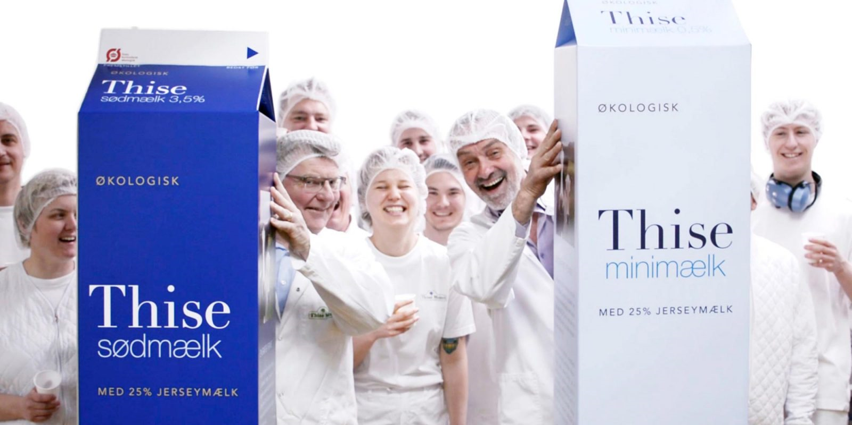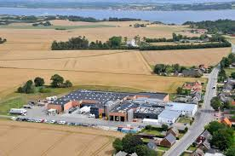
Picture 1: Thise Dairy AMBA – “suppliers”, products, employees and factory.

was about optimize and find new business models for the current utilization of the organic material in the residual different dairy products in best possible way as well as economically. In this case Thise Dairy AMBA would also like to consider business models linked to biogas as an interesting solution.

VEAS TBMI Biogas 2020 challenge - http://www.veas.nu –
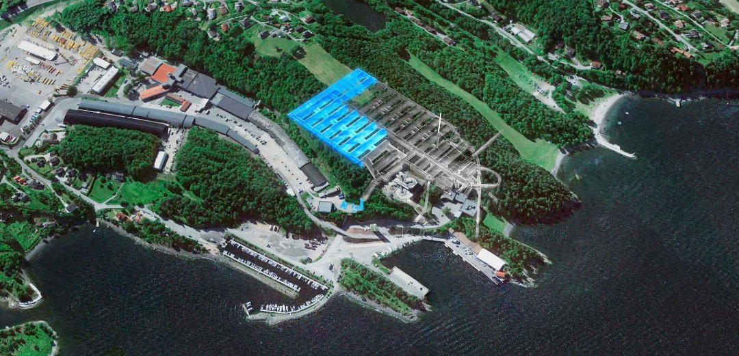
Picture 2: Veas plan and plan for increase of Veas

was about analyzing AS IS business models, not appropriated, and help to create and describe new and improved business models related to “biogas-fakling” (burning gas). There was a very strong motivation to find new and sustainable business models in the Biogas BM ecosystem that can value the society and give environmental effects.

The West Coast Smolt TBMI Biogas 2020 challenge - http://www.smolts.se/

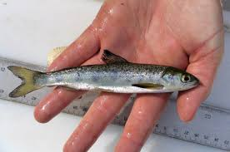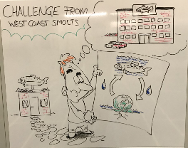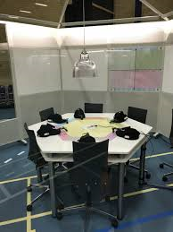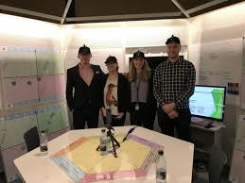
Picture 3: West Coast Smolt and Beelab/Beecube and team behind the Bogas 2020 TBMI Challenge.

involved an analysis of Multi Business Models related to the establishment of a biogas plant of a land-based fish cultivation in Sotenäs Municipality in Sweden. The West Coast Smolts Business want to investigate different solutions with biogas Business Model solutions and the impact of different Business Model solutions related to the businesses involved and connected to fish cultivation and a new biogas plant.

From the universities in the three Nordic countries: Denmark, Norway and Sweden master’s Degree student where invited to participate in a 3-day BMI challenge in relation to the Biogas 2020 conference. The invited students represented different educational programs such as: Innovation and Project Management, University College of Eastfold (HIØ) and Environmental and Life Sciences University (NMBU) Norway: Industrial Economics / Department of Engineering, Land Surveying Engineer, International Political and Economic Policy (IPPE), Industrial Economics / Department of Engineering Sweden, and Master of Science in Engineering - Technology Based Business Development Aarhus University Denmark (our translation). Thirteen of 15 invited students signed up for the challenge and arrived the 6th of November in Skive late in the afternoon, received their group number and information about the challenge. The students were organized with different educational backgrounds and nationality - one with 5 students and two with 4 students.

4.1. Results Biogas 2020 TBMI Challenge

Although it is very early to report on the mega data adapted from the Biogas TBMI Challenge it stands very clear that the use of a common MBMI language and physical tools to visualize the MBMI seems to have large influence on the MBMI process and the knowledge creation, capturing, delivering, receiving and consumption.

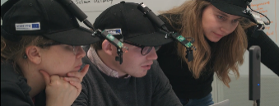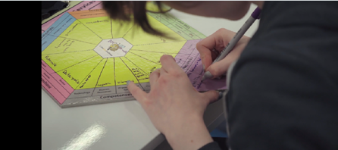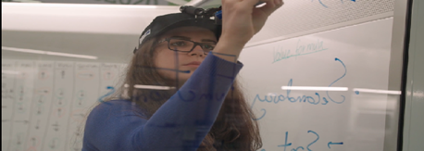
Picture 4: Students working with the MBMI tools in the Beelab/Beecubes.

5.0 Discussions

The outcomes of the two experiments can only be regarded as some very first result on investigating the development of MBMI Competences in businesses, to young students and researchers. The results can on a longer perspective on behalf of more experiments, data mining and detail big data researchand analysis help us to develop better guidelines to development of MBMI competences. The establish knowledge on how to create better MBMI environments in the aim of speeding up MBMI and “production” of “TO BE” BM´s .

The research and experiment indicate clearly that knowledge transfer can be supported by using a manifold of the humans sensors – not just the eye and the ear. Especially the feelings in hand while touching the BM hexagon and drawing in the Beelab/Beecube enables a knowledge transfer on MBMI that seems to be very strong and intense. Combining these observation with the data received from the 360 degree video of the Biogas 2020 TBMI Challenge and the sensors data of humidity, CO2, temperature and pulse data. Here it was possible to observe that the BMI process was very intensified when the use of MBMI tools was used in downloading , seeing and sensing phase.

A clear Task co-representation (the ability to form and continually build on a mental representation of co-actor’s task in the MBMI projects that is going to operated with the MBMI challenge) was seen as the students together with the businesses involved build in both experiment a visual picture of the MBMI challenge and later on proposed solutions.

A Clear joint attention (the ability to attend to a new MBMI tasks, knowledge or events created together during the establishment and evolvement of the MBMI project) was also registered between the students included, between students, businesses and teacher/coaches.

The Learning (the ability to learn better with group members and close together with businesses in MBMI project) – supported by the MBMI physical tools are indicated to be higher and more intense referring to the analysis of the interviews with students, businesses and teachers/coaches.

6. Conclusion
The paper reports on 2 experiments in CGC/MBIT research center carried out with 8 businesses (6 Danish, 1 Norwegian and 1 Swedish Business), 32 vocational, master and PhD students and 6 MBMI coaches. The actors worked close together with business management on different MBMI Challenges with the aim of chaning “AS IS” BM´s and creating and capturing “TO BE” BM´s. The research was carried out within the project Strategy Reborn and EU Interreg. Project Biogas 2020 Challenge was carried out on behalf of a common accepted MBMI Language and physical tools enabling the actors to talk MBMI in the same language with each other and co create visual pictures of the AS IS and TO BE context and plan.

7. Further research
The researchers are now analyzing the large amount of data from the Biogas 2020 TBMI Challenge experiment. This analysis is very time consuming as 10 GB data was generated from the 3 Beelabs/Beecubes every second in the 3 days that the Biogas 2020 TBMI Challenge where carried out. Further another and larger experiment are set up to verify more detailed and stronger, some of the observations and data seen in the Strategy Reborn and TBMI Biogas 2020 experiment. These data and analysis are expected to be reported in autumn 2018.
References
Amidon D. (2005) Knowledge Zone Research-Technology Management Volume/issue:
Vol. 48, No. 1 January-February 2005 Business Enterprises—Management Knowledge Management

Biogas 2020 - http://www.energibyenskive.dk/en/projects/biogas2020/

Lindgren, P and Rasmus Jørgensen (2012) “Towards a multi business model Innovation Model” Journal of Multi Business Model Innovation and Technology River Publisher
Lindgren and Horn Rasmussen (2013) The Business Model Cube Journal of Multi Business Model Innovation and Technology River Publisher
Lindgren, P. (2015) How to establish knowledge sharing from the very first moment in critical and risky Business Model Innovation project, IFKAD 2015 conference in Bari.
Lindgren, Peter; Bandsholm, Jesper; Aagaard, Annabeth (2016) How to establish knowledge sharing in the second phase of a critical and risky Network-based Business Model Innovation project. /
. Paper presented at IFKAD, Dresden, Germany adapted in IFKAD 2016 Proceedings
Lindgren, P and Jesper Bandshom (2016) BM Relation Axiom – 3. Quadrant – the First Phases of Business Model Innovation in a Network-based Business Model Innovation Situation Vol: 4 Issue: 2 Published In: May 2016 Article No: 3 Page: 71-88
Flarup, Jane, Signe Stagstrup Jensen, Peter Lindgren (2017) COMPETENCES of BUSINESS MODEL INNOVATION – “The DNA of BMI” Adapted in Proceedings IFKAD, Skt Peterburg, Russia

Lindgren P. (2014) The Sensing Business Model, Volume 76, Issue 2, pp 291–309 Wireless Personal Communications

Lindgren, P (2017) ….., “Continuous knowledge sharing in the third phase of a critical and risky Network-based Business Model Innovation project” Adapted in Proceeding GWS 2017 IEEE Cape Town, South Africa.
Nalebuff, B., Brandenburger, A., & Maulana, A. (1996). Co-opetition. London: Harper Collins Business.
Porter, Michael E. and Kramer, Mark R. (2011) THE BIG IDEA Creating Shared Value How to reinvent capitalism—and unleash a wave of innovation and growth, Harvard Business Review January–February 2011
Prasad, R 2016 The Knowledge Home -
Sebanz, Natalie et.al, (2006) Joint action: bodies and minds moving together, TRENDS in Cognitive Sciences, Vol.10 No.2,

